**CRITERION B: DESIGN**

1. DATABASE SCHEMA
2. Database Tables

**Table Name:** users

**Description:** Acts as the main database that stores all registered user accounts

|  |  |  |  |
| --- | --- | --- | --- |
| Field Name | Data Type | Description | Validation Rules |
| id | INT | to assign an id to the registered data | Primary key |
| username | Varchar | to save username | - |
| email | Varchar | to save email for login | must be of type email |
| password | Varchar | to save username for login | - |
| phone | Varchar | to save phone number user | must contain 10-15 numbers |
| role | Varchar | to save the user's status | - |

**Table Name:** rooms

**Description:** Acts as the main database that stores all added room data.

|  |  |  |  |
| --- | --- | --- | --- |
| Field Name | Data Type | Description | Validation Rules |
| Id | INT | to assign an id to the registered data | Primary key |
| Image | LongText | to save the room image path | - |
| Name | Varchar | to save name room | - |
| Person | Varchar | to store the capacity of the room | - |
| Size | Varchar | to store the details of the room size | - |
| price | Float | store room prices | must be a number |
| bed | Varchar | saving mattress capacity | - |
| status | Varchar | status is available or booked | - |

**Table Name:** order

**Description:**  Acts as the main database that stores all order room data.

|  |  |  |  |
| --- | --- | --- | --- |
| Field Name | Data Type | Description | Validation Rules |
| Id | INT | to assign an id to the registered data | Primary Key |
| Id_rooms | INT | for the relationship between the rooms table and the order table | Forgein Key |
| name | Varchar | to save the name order | - |
| checkin_date | Date | to save the checkin date | must be a date |
| chekout_date | Date | to save the checkoutdate | must be a date |
| Name_rooms | Varchar | to save the room name | - |
| phone | Varchar | to save phone number user | must contain 10-15 numbers |
| status | Varchar | status is available or booked | - |

**Table Name:** arship

**Description:** to summarise the history of orders that have been placed.

|  |  |  |  |
| --- | --- | --- | --- |
| Field Name | Data Type | Description | Validation Rules |
| Id | INT | to assign an id to the registered data | Primary Key |
| name | Varchar | to save the name order | - |
| checkin_date | Date | to save the checkin date | must be a date |
| chekout_date | Date | to save the checkoutdate | must be a date |
| Name_rooms | Varchar | to save the room name | - |
| phone | Varchar | to save phone number user | must contain 10-15 numbers |
| status | Varchar | status is available or booked | - |

* 1. ENTITY-RELATIONSHIP DIAGRAMS

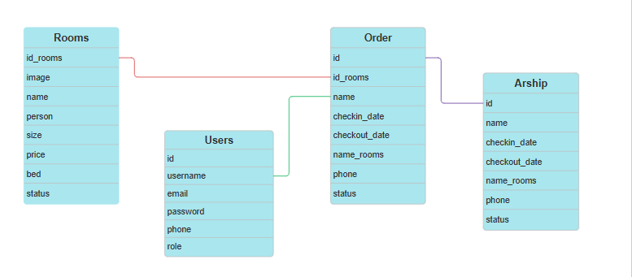

Fig1.1. 1 Flow data Reference

1. USER INTERFACE DESIGN OVERVIEW
   1. INTRODUCTION

The wireframes would be designed using wireferame cc, while flowcharts are created in draw.io

* 1. COLOR PALETTE

The client has requested a redesign of a villa booking system to better reflect the villa's branding and preferred color scheme. Currently, the system uses white as the main color, with deep blue (#2E5284) and green-gray (#6F8D6B) as primary colors, and gold (#E3BD34) and coral (#E5572E) as accent colors. The client wants a visually cohesive design that mirrors the villa's elegant and inviting atmosphere. The existing user interface (UI) contains excessive empty space, which reduces readability and detracts from the overall user experience (UX). Additionally, the current color and design choices make the system appear outdated and less engaging. In the redesign, the client envisions a clean, modern aesthetic that is user-friendly, engaging, and visually appealing, creating an immersive booking experience that reflects the villa's unique charm and warmth.

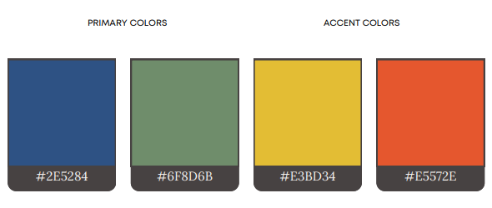

Fig2.2. 1 Color Palette

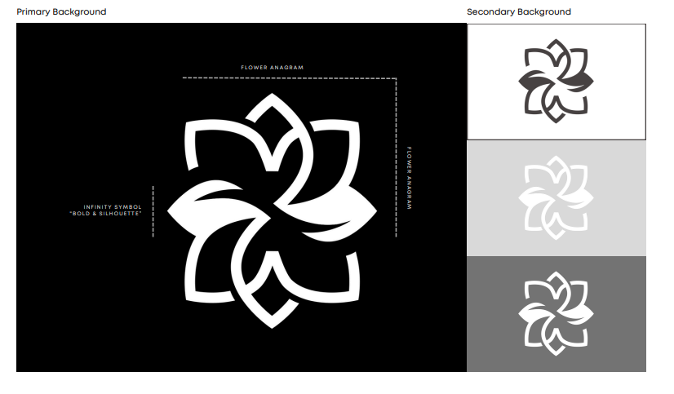

Fig2.2. 2Variations of the System's Logo and Name Display

* 1. WIREFRAME: USER LOGIN

System`s logo

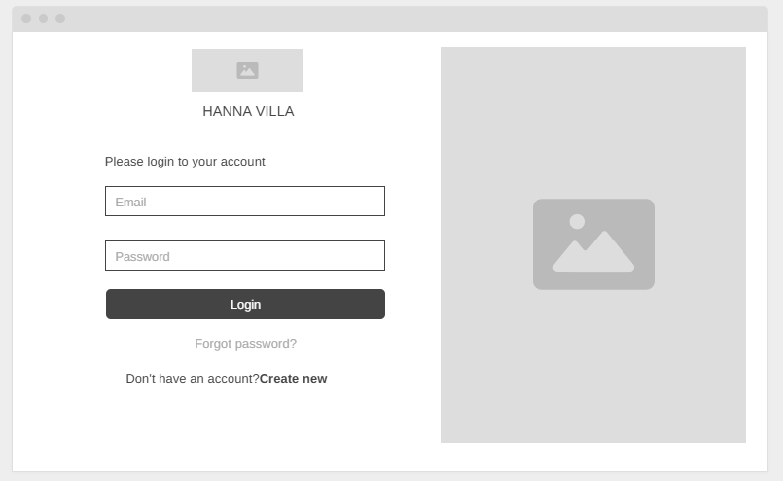

redirects to the page to create an account

redirects to the page to recover the account

Organization`s logo

Fig2.2. 3 Login page

The login screen will be the initial entry point for every user when they visit the website. Since both fields are required to identify and verify the user successfully, once the submit button is pressed, the system will first validate that all fields are filled. If they match successfully, the system will perform a process to determine the page between the user and the admin.

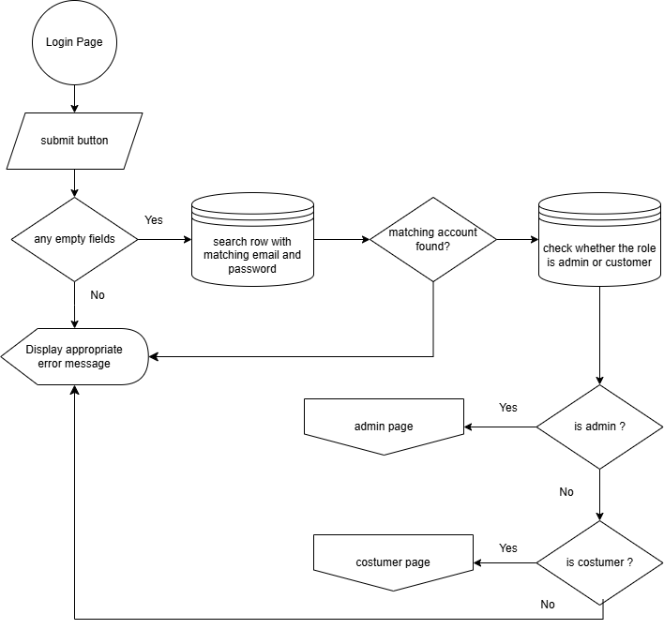

Fig2.2. 4 Login Flowchart

* 1. WIREFRAME: ACCOUNT REGISTRASION

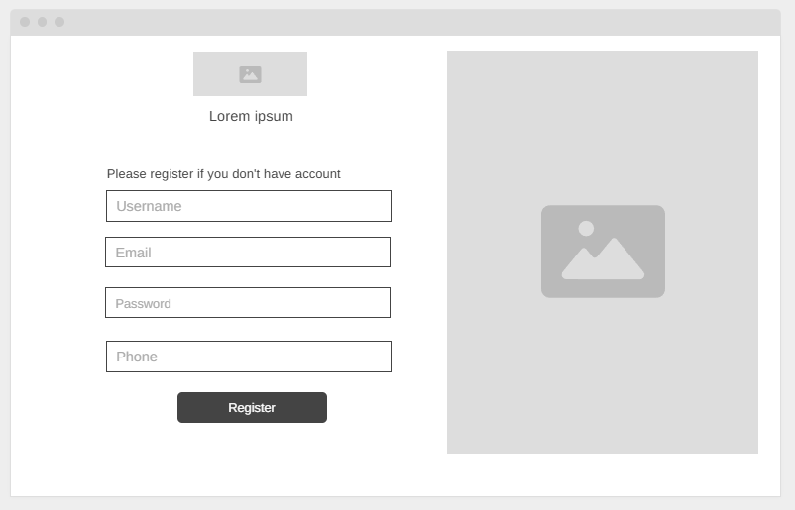

redirects to the register process

Fig2.2. 5 Registration Page

in order to create a registration account the user must provide a valid email because an otp code will be sent to a valid email.

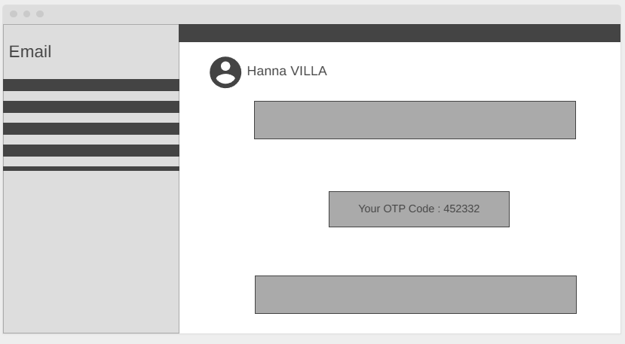

Randomly Generate 6 -digit otp

Fig2.2. 6 OTP Code Email Notification

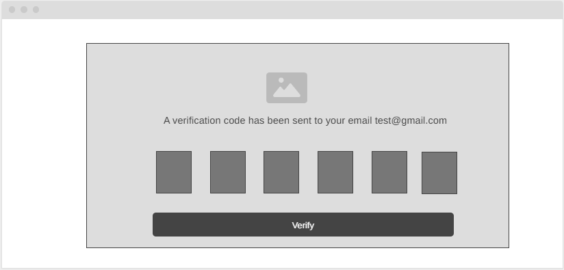

Input fileds for 6-digit otp

Fig2.2. Insert OTP Code Page

Submit process verify otp code

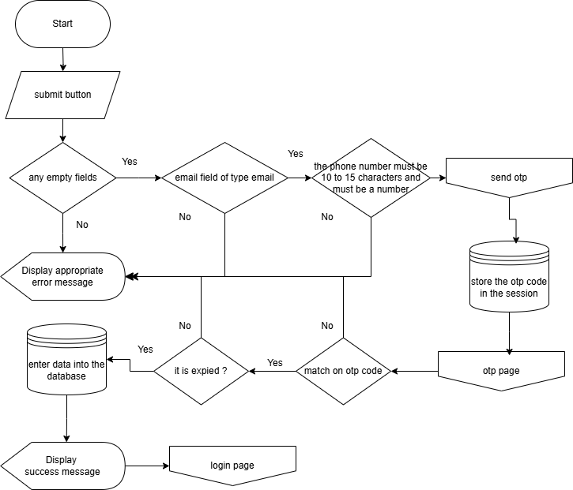

* 1. WIREFRAME: FORGOT PASSWORD

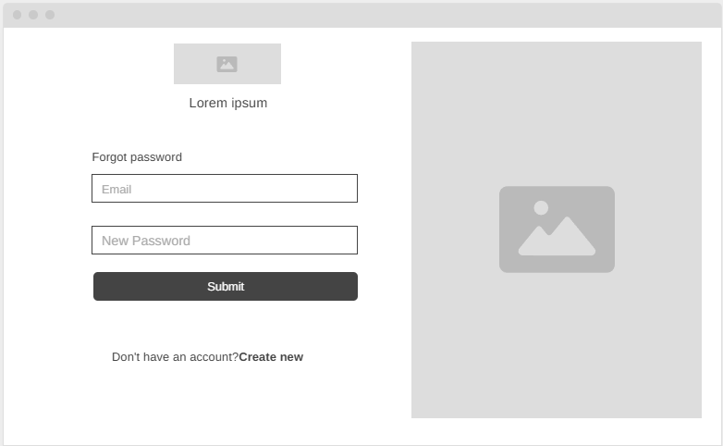

Input fileds for email

Input fileds for new password

If a user forgets their assigned account password and chooses to initiate the password recovery process password recovery process, they will be redirected to a dedicated page where they will be required to provide and new password and then submit an OTP code for two-step authentication.



Randomly Generate 6 -digit otp



Input fileds for 6-digit otp

Submit process verify otp code

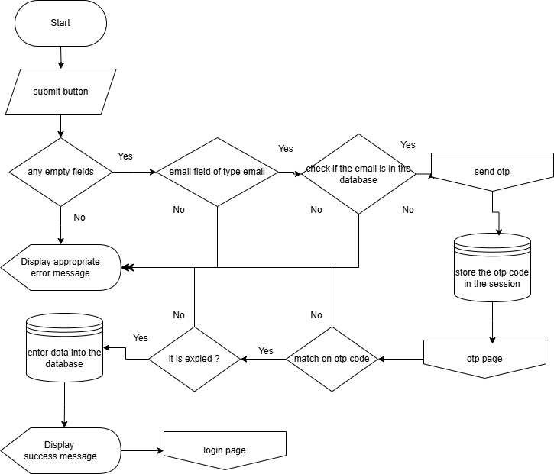

Fig2.2. 8 Registration Flowchart

* 1. WIREFRAME: BOOK ROOMS

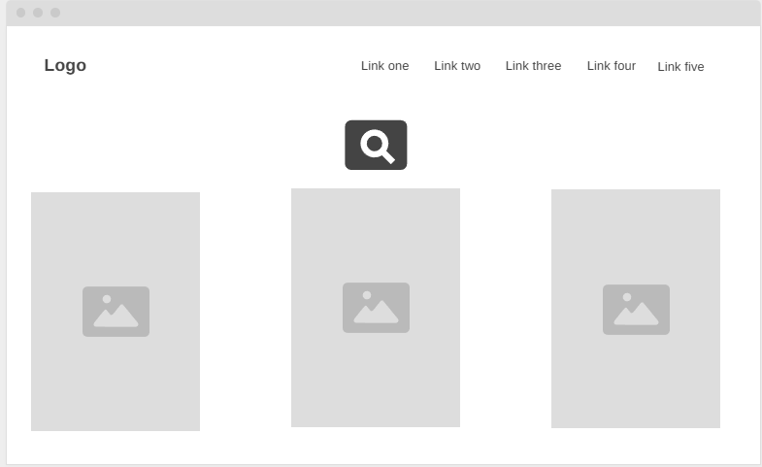

Detail rooms and image

Menu page

Search for rooms

Fig2.2. 9 Rooms Page

on the rooms page there is detailed information about the rooms available for booking and displaying images and there is a search bar to search for rooms.

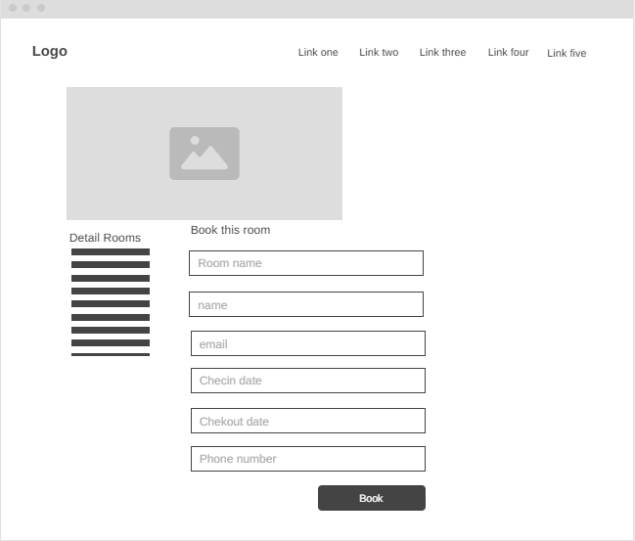

Submit book

Form for book rooms

Information detail rooms

Image rooms

Fig2.2. 10 Detail Rooms and Book Page

if detail rooms is clicked, it will bring up detailed information and the status of the room has been booked or not and there is a room booking form.

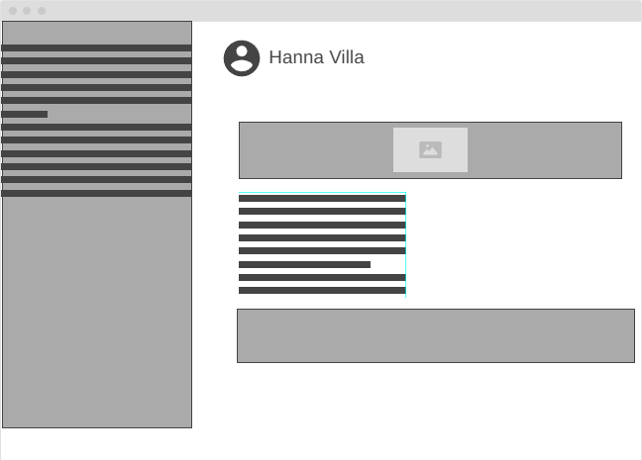

Navbar footer

Footer message

Information detail book

Fig2.2. 11 Detail Order Information Email Notification

If the room is successfully booked, the message details and order receipt will be emailed to you.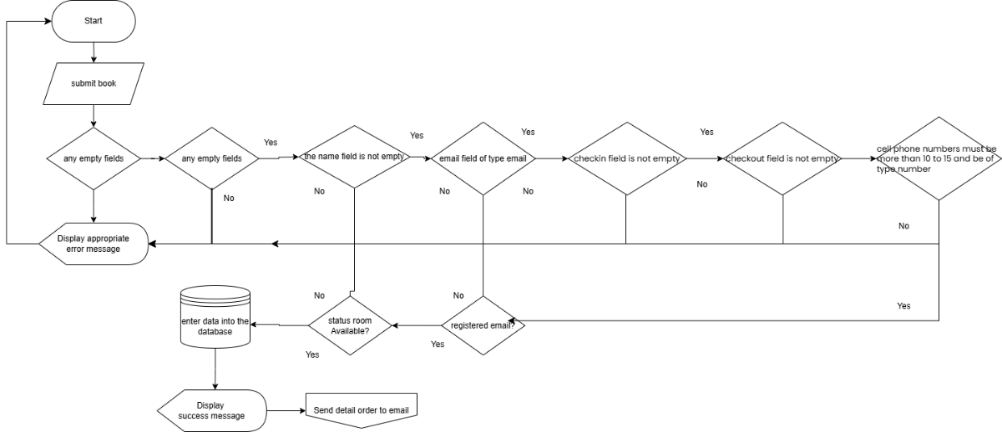

Fig2.2. 12 Flow Chart Book Rooms

* 1. WIREFRAME: DASHBOARD ADMIN

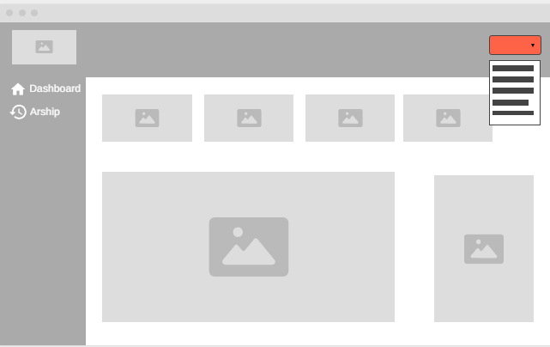

Exit menu

order digram for a day

order digram for a month

Information order

Menu Page

Fig2.2. 13 Admin Page

Button popup for add admin

* 1. WIREFRAME: ADD ADMIN

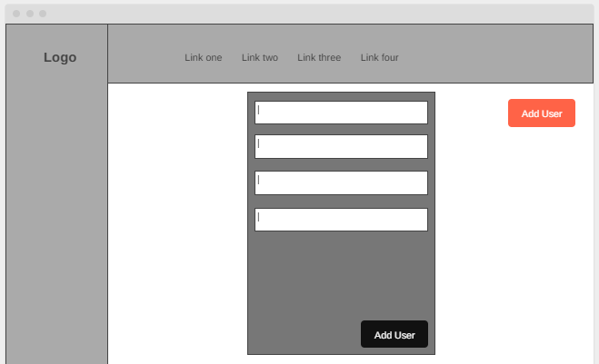

Popup form add admin

Submit add admin

* 1. WIREFRAME: ADD ROOM

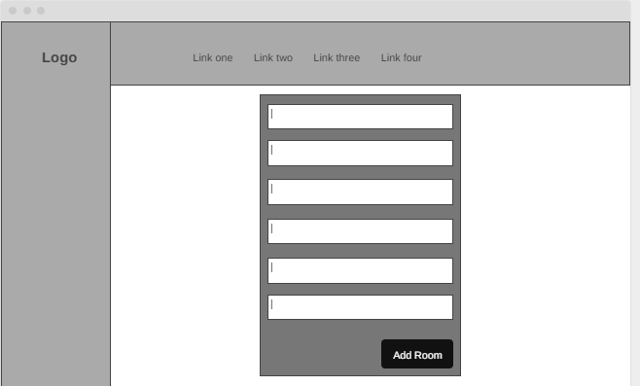

Button for submit add room

Popup form add room

* 1. WIREFRAME: ADD ROOM

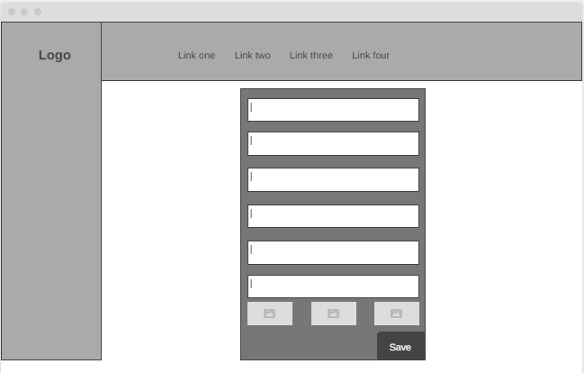

Button for submit edit room

Popup form edit room

* 1. WIREFRAME: ADD ROOM

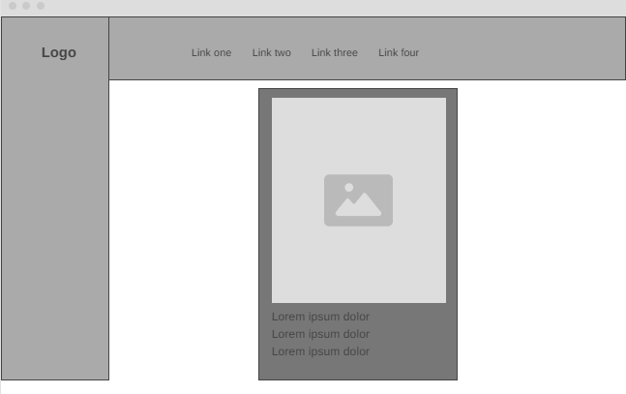

Description room

Image rooms

Popup details room

1. TEST PLAN

|  |  |  |
| --- | --- | --- |
| Test type | Nature OF TEST | EXAMPLE |
| Valid localhost connection | Verify that a graphical user interface (GUI) is displayed upon running the PHP file | Run the entry point file through the localhost server in Google Chrome |
| Input validation | Ensure that the system prompts the user to re-type their inputs upon receiving incomplete or incorrect input(s) | If the user types an email address in the wrong format, the program would show a message of the intended structure |
| Database interaction | Confirm that the system can successfully  read from and write to the MySQL database | MySQL database  If the user sends a request to register  a new account, the system will  will first check if there is the same email  and email if the email has not been registered. then the data can be entered into the database. |
| Page redirection | Validate that pressing a specific button redirects the user to the intended page | If the user clicks the button to switch to  account registration mode on the login  page, the page will shift to display the  sign-up page |
| Access control | Verify that the system authenticates the inputs to only grant access to registered users | If a user attempts to log in with a non-existent account, an error message is displayed, and the user is redirected to the login and registration page |
| OTP functionality | Validate OTP generation functionality  OTP generation, sending and verification | The system would send an email to the user’s email address with the 6-digit OTP that they need to input |